A PROJECT REPORT ON

**“School Management”**

DEVELOPED FOR

**Osumare Marketing Solutions PVT.LTD.**

BY

Neha Shantaram Bhoge

FOR THE PARTIAL FULFILLMENT OF THE DEGREE

MASTER OF COMPUTER APPLICATIONS

SUBMITTED TO



KCES’s INSTITUTE OF MANAGEMENT AND RESEARCH, JALGAON

AFFILIATED TO

KBC NORTH MAHARASHTRA UNIVERSITY, JALGAON

2024-2025

Certificate

**To whomsoever it may concern**

This is to certify that Mr. / Ms. Neha Shantaram Bhoge a student of MCA (Master of Computer Application) from Institute of Management and Research, Jalgaon has completed the full me Industrial Training with project titled “**School Management”** at **Passion Software**. She has submitted satisfactory report in par al fulfilment of the requirement for the award of the degree of Master of Computer Application (MCA) during academic year 2024-2025.

|  |  |  |
| --- | --- | --- |
| (Ms. Rupali Narkhade) |  | (Mr. Uday Chatur) |
| Internal Guide |  | Head, Dept. of MCA |
| (Dr. Tanuja Fegade) |  | (Prof. B. V. Pawar) |
| School Director, |  | Director, IMR Jalgaon |
| School of Computer Applications |  |  |
| Internal Examiner |  | External Examiner |

**Declaration**

I, the undersigned hereby declare that the project titled **“School Management”,** being submitted for the award of degree of **Master of Computer Application by me to KCES’s INSTITUTE OF MANAGEMENT AND RESEARCH, JALGAON affiliated to North Maharashtra University, Jalgaon** is the result of an independent work carried out under the guidance of **Prof. Rupali Narkhade**, is my original work. Further I declare that this project has not been submitted to this or any

Institution for the award of any degree.

**Date : 25/05/2025**

**Place : Jalgaon Neha Bhoge**

**ACKNOWLEDGEMENT**

We would like to take this opportunity to thank the people who directly or indirectly enabled to work on this project. At the outset, we would like to thank entire staff of **KCES’s INSTITUTE OF MANAGEMENT AND RESEARCH, JALGAON** both the teaching and non-teaching staff for their continuous and unrelenting efforts in helping us with our project. Without them, these efforts would not have given us expected results.

I started this project as part of the curriculum of **KCES’s INSTITUTE OF MANAGEMENT AND RESEARCH, JALGAON – MCA (Sem - 4).** During this work I have gained both practical as well as theoretical knowledge of great significance. Now after the completion of the project I feel very pleased to present this project report. Also, would like to take this opportunity to thank all those who helped us to complete the project.

I would like to thanks **Prof. B. V. Pawar (Director)**. I am extremely grateful to our Internal Project Guide **Prof. Rupali Narkhade** her constant and valuable encouragement. It is their inexorable direction and profound experience that motivated and inspired us.

Finally, my heartfelt appreciation to my team mate for their valuable advice and timely support. Expressing our hearty gratitude. Thank you

**Chetana Mor**

**Index**

|  |  |  |
| --- | --- | --- |
| **Chapter** | **Topic** | **Page No.** |
|  | **INTRODUCTION** |  |
| 1 | Company Profile | 8 |
| 2 | Abstract | 9 |
| 3 | Existing System and Need for System | 11 |
| 4 | Scope of System | 13 |
| 5 | Operating Environment- Hardware and Software | 14 |
| 6 | Brief Description of Technology Used | 16 |
|  | **PROPOSED SYSTEM** |  |
| 1 | Feasibility Study | 20 |
| 2 | Objectives of Proposed System | 22 |
| 3 | User Requirements | 23 |
|  | **ANALYSIS & DESIGN** |  |
| 1 | System Requirements (Functional and Non-Functional  Survey) | 25 |
| 2 | Data Flow Diagrams (DFD) | 30 |
| 3 | Database Design |  |
| 4 | Entity Relationship Diagram (ERD) | 38 |
| 6 | User Interface Designs | 47 |
|  | **CODING** |  |
| 1 | Algorithms |  |
| 2 | Code Snippet(Sample Code) |  |
|  | **CONCLUSION** |  |
|  | **BIBLIOGRAPHY** |  |

1.1**History of the Organization**

SkillVertex is an AI-Based Online learning platform that provides students with a holistic learning experience to help make them industry-ready. With access to the Industry Experts, Online Courses and blended learning, it allows students to Learn Here and Lead Anywhere.

Degrees tend to teach theoretical concepts in classrooms. Students graduate with blind spots and absolutely no practical exposure to the job environment. We, at SkillVertex, bridge the gap between classroom and workplace with our flagship Internship Programs. We help studentsachieve more holistic education and prepare them for better career opportunities.

SkillVertex acts as an invisible mentor to students, creating channels to unleash their learning potential. It provides access to a wide variety of training programs, hackathons, and projects. These programs are interactive, collaborative and give access to mentors and experts. With SkillVertex, you can find Internships and Job Opportunities seamlessly.

SkillVertex has collaborated with technical moguls to create an immersive platform. With AI- based software at its core, it offers a connected ecosystem accessible from anywhere and byanyone.

Learning through SkillVertex is fun, interactive and practical empowering students to Lead Anywhere, Anyplace and Everywhere.

* + 1. **Objectives**

We are an innovative organization with a goal to impart the aspiring learners with rigorous training and appropriate exposure for a promising future. We believe that pragmatic abilities weigh more over the educational degree. We strive forward to provide an existence where you can find your energy and transform it into your vocation. With a vision of a world loaded

with opportunities and conceivable outcomes, we‟ll help you build a completely certain and assured foundation to stake guarantee on your skills for a brilliant future that awaits

* + 1. **Operation of the Organization**

There are a lot of applications for every skill we learn: We tend to have ample knowledge about various careers and career opportunities. Our responsibilities include maintaining a school's curriculum by identifying and providing student needs, improving school needs, holding school meetings, and monitoring the teacher performances. The education consultants also generally answer the student questions onvarious career options, curriculum, etc.

They also many a times develop instructional materials, provide guidelines to instructors, incorporate current technology, coordinate educational content, and develop the curriculum. The main responsibilities of our organization is identifying the student needs. The education consultant unearths new findings that may help in improving the school programs. The education consultant may even engage in a variety of activities to maximize the productivity and ensure student success.

The education consultants play a major role in purchasing new educational books, computer software, and other essential student requirements. He or she may also arrange for various training courses to enhance the teaching capabilities of the teachers. The education consultants are even responsible for interacting with the staff to understand the essential requirements of the students as well as the organization. They conduct periodic meetings to ensure that the different departments within the school cooperate with each other in any common job duties.

We deal and come across through a lot of institutes with poor educational methodologies and conditioning. According to the statistics in only Punjab region 67% of schools and 53% of colleges run obsolete educational processes.

There are a lot of schools who need proper guidance in terms of the operations. Education is now foreseen as a good business opportunity and the right care isn‟t been taken in establishing one, whereas the prime objective must be quality of education. Coordination can be applied in various team coordination just like coordinating betweenoperation and sales team.Coordination is a vital part in a company, without coordination a company‟s functioning will stop and due to collapses and delay in deadlines finally the operations of the company will stop, and the company will get closed.

Coordination can be applied in Software development as well where we create different classes to access different types of data and then with these classes, we coordinate the data types to provide the input. Problem Solving: Problem Solving have different applications in corporate world.

Problem solving can be applied to various fields as well like resolving the issues of clientsand getting the things done for the clients. Problem solving can be applied to architecture filed for knowing the exact material for building or client management in some sales company. It can be applied in coding or softwaredevelopment as well.

Training: Training or teaching has been there for ages and we all know what its applications are: MNCs recruit different candidates and then train them according to their demands so they can work for the welfare of the company

* 1. **Major Milestones**

Help students, globally, realize their full potential. Partnership Education helps students realize their individual potentials by recognizing that excellence in learning is connected to long- range personal development. Students come to school with multiple and complex issues that cannot be resolved by school alone. Partnership schools/programs work with the community to support students and families.

Accountability is a major topic in today's education world. However, the word accountability conjures up images of rewards and sanctions imposed by an external force. Responsibility is internally driven rather than externally imposed.

There has been a tendency to assume that nurturing communities or schools based on caring are somehow contradictory to the tenets of accountability, i.e., ensuring excellence in learning. In fact, it is in nurturing communities of learning that young people can freely

actualize their human striving to excel, to be the best they can be. In partnership schools/programs, staff have a deep commitment to ensure that each child progresses and learns, and assumes responsibility.

Partnership Education recognizes that excellence in learning is connected to long-range personal development, which includes both academic (cognitive domain) and social/emotional (affective domain) development. Excellence cannot be measured only by tests designed to sort students and measure academic progress in comparison to what others know. True excellence in education focuses on the whole student as a unique individual, and is best measured using a variety of integrative assessment approaches that incorporate multiple formats for reporting what students have really learned.

To provide AI-enabled real-time insights with the resolution of reaching a broad community of individuals to help acquire skills that they want. To ensure that students realize their true potential while learning with us and stand to be the face of the cyber-age with razor-sharp thinking and practical ability to execute tough ideas and decisions.

In the future, artificial intelligence (AI) is likely to substantially change both marketing strategies and customer behaviors. Building from not only extant research but also extensive interactions of AI involving intelligence levels, task types, and whether AI is embedded in a robot. Prior research typically addresses a subset of these dimensions; this paper integrates all three into a single framework. Next, the authors propose a research agenda that addresses not only how marketing strategies and customer behaviors will change in the future, but also highlights important policy questions relating to privacy, bias and ethics. Finally, the authors suggest AI will be more effective if it augments (rather than replaces) human managers.

SkillVertex plans to use the funds for marketing, expansion, and research and development of the product The startup wants to help bridge the gap a student faces between the classroom environment and the workplace through training .With more than 15K registered students, SkillVertex will soon offer electronics and roboticscourses as well.

* 1. **Structure of the Organization**

Every skill that we learn, or gain have different scopes and each skill plays a vital role, The Scope of the work is to basically improve the education standards in underdeveloped private institutes. In a country where we believe education is the key to success and being the highest populated country in the age groups of 6-18. The education methodologies and practices have a deliberate need to be updated and relevant. Improper education methodologies can actually cause more harm to a student. Solving the problem of mismanagement and poor conditioning of schools the aim is to create suitable environment for the younger generations to live the best phase of their lives with proper education and conditioning. India and many populated countries have large number of schools, but many of them still run outdated methods and poor conditioning for students.

Coordination is very essential in management. Business has various functions. These functions are performed by different individuals. Moreover, performance of these functions requires division of work and grouping of activities and making decisions at different levels.

All these necessitate co-ordination for attaining the desired goals. Co-ordination is concerned with synchronizing, integrating or unifying all the group actions in an enterprise to achieve its objectives. It is a process by which the manager achieves harmonious group efforts and unity of actions through balancing the activities of different individuals and groups of individuals and reconciling their differences in interest or approach, for the attainment of common goals. In the words of McFarland,

“Co-ordination is the process whereby an executive develops an orderly pattern of group efforts among his subordinates and secures unity of actions in the pursuit of a common purpose.”

Problem Solving: Having good, strong problem-solving skills can make a huge difference to your career. Problems are at the center of what many people do at work every day. Whether you are solving a problem for a client (internal or external), supporting those who are solving problems, or discovering new problems to solve, the problems you face can be large or small, simple or complex, and easy or difficult.

A fundamental part of every role is finding ways to solve them. So, being a confident problem solver is important to your success. Much of that confidence comes from having a good process to use when approaching a problem. With one, you can solve problems quickly and effectively. Without one, your solutions may be ineffective, or you will get stuck and do nothing, with sometimes painful consequences.

# ABSTRACT

# Name Of The Project: “School Management”

# Name Of Client : Umesh Ahirrao

Name: Neha Bhoge Class: MCA SY

Roll. No. : Semester: IV

# Introduction

The **School Management System** is a full-stack web application designed to digitalize and streamline the day-to-day operations of educational institutions. It supports three main user roles: Admin, Teacher, and Student, each with specific access and functionalities tailored to their needs. Admins can manage users, classes, subjects, timetables, attendance, and reports.

Teachers can view their assigned classes, mark attendance, upload study materials, assign and grade homework, and communicate with students. Students can access their timetables, assignments, grades, attendance records, and receive important announcements. The system aims to reduce manual paperwork, enhance communication, and provide a centralized platform for managing academic and administrative activities efficiently.

Built using modern web technologies, the application ensures secure login, real-time updates, and an intuitive user interface for a seamless user experience.

* **Modules:**

There are the following modules in the project

1. Login and Register: It has 3 Dashboards namely Admin, Teacher and User
2. Student Account create
3. View Student Dashboard
4. ManageStudent:
   1. Manage Student
   2. Delete Student
   3. Edit Student
5. Manage Teacher
   1. Select Subject
6. Create Class
7. Add Events
   1. **Existing System And Need For System:**

**Existing System:**

1. Most schools rely on manual record-keeping using paper files or basic spreadsheet tools.
2. Attendance is often tracked on paper registers, making it prone to errors and loss.
3. Timetable creation and exam scheduling are done manually, leading to time-consuming processes.
4. Communication between teachers, students, and parents is limited to physical meetings or phone calls.
5. There is no centralized system to manage student data, teacher assignments, or class schedules.
6. Administrative tasks like student admissions, fee tracking, and result management are inefficient and lack automation.
7. Access to information is not real-time, and reports are difficult to generate without manual effort.

**Need for the System:**

1. To digitalize and automate administrative and academic tasks, reducing paperwork and human error.
2. To provide a centralized platform for managing students, teachers, classes, and academic records.
3. To enable real-time access to attendance, results, and schedules for students, teachers, and admins.
4. To improve communication among students, teachers, and parents through an integrated system.
5. To streamline processes such as admissions, fee management, and academic performance tracking.
6. To enhance data security, transparency, and ease of use through role-based access control.
7. To generate accurate reports and insights for better decision-making and school managemen

**1.4 Scope of the System:**

1. The system is designed to manage the academic and administrative operations of schools efficiently and digitally.
2. It supports role-based access for Admins, Teachers, and Students, each with specific permissions and dashboards.
3. Admins can manage users, classes, subjects, timetables, events, blogs, FAQs, and subscriptions through a centralized panel.
4. Teachers can manage class attendance, upload study materials, assign and evaluate homework, and interact with students.
5. Students can view their dashboard with attendance, assignments, grades, class schedules, and announcements.
6. The system includes profile management modules for Admins, Agents, and Users to update their information securely.
7. It facilitates communication and engagement through blog posting, events, and FAQs.
8. The application can be accessed from any device with an internet connection, making it scalable and user-friendly.
9. It reduces manual workload, minimizes errors, and ensures real-time updates for all stakeholders.

**1.5 Operation Environment: Hardware and Software**

**Hardware Requirements**

The operation of the **School Management System** requires hardware resources that can support both the frontend and backend services efficiently. Below are the minimum recommended hardware specifications:

**Server Infrastructure:**

* High-performance servers to handle multiple user requests, database operations, and backend logic processing.
* Adequate storage capacity to store student records, documents, assignments, reports, and multimedia content.
* Stable and fast internet connectivity to ensure smooth, uninterrupted access for all users.

**Client Devices:**

* Desktop computers, laptops, tablets, or smartphones for accessing the system.
* Devices should have sufficient processing power, memory (minimum 4GB RAM), and display resolution to support responsive web browsing.
* Modern web browsers such as Google Chrome, Mozilla Firefox, Microsoft Edge, or Safari for accessing the application.

**Software Requirements**

The School Management System relies on a range of software components to deliver robust, scalable, and interactive functionality across its modules. The required software includes:

**Operating System:**

For servers: Linux-based operating systems such as Ubuntu Server, CentOS, or Debian.

For client devices: Any modern operating system compatible with popular web browsers, including Windows, macOS, Linux, Android, and iOS.

**Web Server:**

Backend services will be hosted on a web server capable of running Node.js applications. Recommended web servers include Nginx or Apache, configured to proxy requests to the Node.js application server.

**Database:**

MongoDB will be used as the primary database management system (DBMS) for storing property data, user information, and other relevant data.

The latest stable version of MongoDB should be installed and configured on the server infrastructure.

**Backend Framework:**

The backend of School Management will be developed using the MERN (MongoDB, Express.js, React.js, Node.js) stack.

Node.js will serve as the runtime environment for executing server-side JavaScript code. Express.js will be used as the web application framework for building the backend API. **Frontend Framework:**

The frontend of School Management, will be developed using React.js, a popular JavaScript library for building user interfaces.

React.js enables the creation of interactive, responsive, and dynamic user interfaces, enhancing the overall user experience.

**Frontend Technologies**

**React.js**

React.js stands as the cornerstone of School Management frontend architecture, offering a powerful and efficient way to build reusable UI components. Its declarative nature simplifies the creation of complex user interfaces by breaking them down into smaller, manageable components. React's Virtual DOM ensures optimal performance by minimizing unnecessary re-renders and efficiently updating the UI when data changes.

**Tailwind CSS**

Tailwind CSS emerges as a revolutionary utility-first CSS framework that enables developers to design custom, responsive, and visually stunning interfaces with ease. Unlike traditional CSS frameworks, Tailwind CSS provides a comprehensive set of utility classes that allow developers to style elements directly in HTML markup, eliminating the need for custom CSS.

**Axios**

Axios emerges as a versatile and feature-rich HTTP client for making asynchronous requests from the frontend to the backend server. Its intuitive API simplifies the process of sending HTTP requests and handling responses, offering robust support for various request methods, data formats, and interceptors. Axios seamlessly integrates with modern JavaScript frameworks and libraries, including React.js, making it an ideal choice for communicating with RESTfu

**Backend Technologies**

**Node.js**

Node.js revolutionizes server-side development with its event-driven, non-blocking I/O model and lightweight architecture. It allows developers to build fast, scalable, and efficient web applications using JavaScript, both on the frontend and backend. Node.js leverages the V8 JavaScript engine to execute JavaScript code efficiently, enabling seamless handling of HTTP requests, database operations, and business logic. School Management harnesses the power of Node.js as its backend runtime environment, ensuring optimal performance, scalability, and flexibility in handling concurrent connections and processing requests.

**Express.js**

Express.js stands as a minimalist and flexible web application framework for Node.js, designed for building robust and scalable APIs and web servers. Its lightweight and unopinionated nature makes it ideal for developing RESTful APIs and handling middleware functions efficiently. Express.js simplifies the process of defining routes, handling requests, and managing middleware, enabling developers to focus on building core application logic. School Management adopts Express.js as its backend framework to define RESTful endpoints, implement middleware, and handle HTTP requests effectively, facilitating the development of a reliable and high-performance backend API.

**MongoDB and Mongoose**

MongoDB emerges as a leading NoSQL database management system renowned for its flexibility, scalability, and performance. It employs a document-oriented data model to store data in flexible, JSON-like documents, offering rich query capabilities and horizontal scalability. MongoDB's flexible schema allows developers to store semi-structured data and adapt to evolving requirements seamlessly.

**Chapter 2**

**PROPOSED SYSTEM**

* 1. **Feasibility Study**

**Technical Feasibility**

**Assessment of Technology Stack**

**Compatibility:** Evaluate the compatibility of chosen technologies (MERN stack, Firebase, etc.) with project requirements.

**Scalability:** Assess the scalability of the system to accommodate future growth in users, data, and features.

**Security:** Ensure that the chosen technologies provide adequate security measures to protect user data .

**Integration**: Evaluate the ease of integration with third-party services (Cloudinary, Firebase OTP verification, etc.).

**Development Resources:** Assess the availability of skilled developers proficient in the chosen technologies.

**Infrastructure Requirements**

**Hardware:** Determine the hardware requirements for hosting the system, including servers, storage, and networking equipment.

**Software:** Identify the software dependencies and licenses required for development, deployment, and maintenance.

**Cloud Services:** Evaluate the feasibility of using cloud services (e.g., AWS, Heroku) for hosting and scaling the application.

**Economic Feasibility**

**Cost-Benefit Analysis**

**Development Costs**: Estimate the costs associated with software development, including salaries, licenses, and development tools.

**Infrastructure Costs:** Calculate the costs of hardware, software, and cloud services required for hosting the system.

* 1. **Objectives of the School Management System**

1. **Digital Transformation**:

To digitalize all major school activities such as student enrollment, class scheduling, attendance tracking, and academic performance monitoring.

1. **Centralized Management**:

To provide a unified platform for managing students, teachers, classes, subjects, events, and administrative tasks.

1. **Role-Based Access**:

To ensure secure and appropriate access through separate dashboards for Admins, Teachers, and Students.

1. **Efficient Communication**:

To enhance communication between teachers, students, and administrators through real-time notifications, blogs, and event updates.

1. **Automation of Routine Tasks**:

To automate repetitive administrative tasks like attendance recording, timetable generation, and report card creation, reducing manual workload and human error.

1. **User-Friendly Interface**:

To deliver an intuitive and easy-to-use interface for all users, regardless of technical expertise.

1. **Data Accuracy and Security**:

To maintain accurate student and teacher data while ensuring privacy and security through authentication and role-based restrictions.

1. **Performance Tracking**:

To enable teachers and admins to track and analyze academic performance over time for better decision-making.

1. **Scalability and Flexibility**:

To build a system that can be easily expanded with new features or integrated with other educational tools as the institution grows.

1. **Paperless Environment**:

To reduce paper usage and physical storage needs by maintaining all academic records digitally

* 1. **User System Requirements for School Management:-**

**Hardware Requirements**

**Desktop/Laptop:**

**Operating System:** Windows 7 or later, macOS, Linux

**Processor:** Intel Core i3 or equivalent

**RAM:** 4GB or higher

**Storage:** 250GB HDD/SSD or higher

**Mobile Devices:**

**Operating System:** Android 5.0 or later, iOS 11 or later

**Processor:** Quad-core or higher

**RAM:** 2GB or higher

**Storage:** 32GB or higher

**Screen Size:** 4.5 inches or larger

**Software Requirements**

**Web Browser:**

**Recommended Browsers:** Google Chrome, Mozilla Firefox, Safari, Microsoft Edge

**Mobile App:**

Compatible with Android and iOS devices Latest Version available on respective app stores **Internet Connection**

**Broadband Connection:**

**Minimum Speed:** 5 Mbps for optimal performance

Stable Connection to browse listings, view images, and stream virtual tours without interruptions

**Additional Requirements:**

**Location Services:**

Enabled for mobile devices to facilitate map-based property search and location-based services

**Camera and Microphone:**

Access required for virtual property tours, video calls, and uploading images/videos of properties

**Account Registration:**

Email address or phone number for account registration and verification.



**3.1 System Requirements: Functional and Non-Functional Requirements**

Functional requirements define the specific behavior and functions of the School Management System. These are the essential features the system must support to meet user and business needs.

**1. User Authentication and Role Management**

* **FR1:** The system shall allow users to register and log in as Admin, Teacher, or Student.
* **FR2:** The system shall restrict access to specific features based on the user's role.

**2. Student Management**

* **FR3:** The Admin shall be able to add, edit, view, and delete student records.
* **FR4:** The system shall display individual student dashboards with academic and personal information.

**3. Teacher Management**

* **FR5:** The Admin shall be able to add, edit, assign subjects, and delete teacher profiles.
* **FR6:** Teachers shall have access to view their assigned subjects and manage student grades and attendance.

**4. Class and Subject Management**

* **FR7:** The system shall allow the Admin to create, update, and manage class schedules and subjects.
* **FR8:** Teachers should be able to manage class materials and schedules for their assigned classes.

**5. Attendance Tracking**

* **FR9:** Teachers shall be able to mark and update student attendance.
* **FR10:** Students and parents shall be able to view attendance records.

**6. Events and Announcements**

* **FR11:** Admin shall be able to create, edit, and publish school events and notices.
* **FR12:** Students and teachers shall be notified of upcoming events.

**7. Blog/Content Management**

* **FR13:** Admin and authorized users shall be able to post, edit, and delete blogs or news articles.
* **FR14:** All users shall be able to view published content.

**8. Profile Management**

* **FR15:** Users shall be able to view and edit their own profile information (Admin, Teacher, Student).
* **FR16:** Admin shall have the ability to manage profiles of all user types.

**9. FAQ and Support**

* **FR17:** Admin shall be able to manage FAQs for helping users navigate and use the system effectively.

**10. Subscription or Fee Management (If included)**

* **FR18:** Admin shall be able to manage student subscriptions or fee-related data (optional module based on scope).

**Non-Functional Requirements – School Management System**

**1. Performance**

* **NFR1:** The system should be responsive and capable of handling multiple users (students, teachers, admins) simultaneously without noticeable delays.
* **NFR2:** Dashboards, attendance data, academic reports, and class schedules should load quickly with minimal latency.

1. **Security**

* **NFR3:** All user authentication, data transfers, and communications must be encrypted using secure protocols (e.g., HTTPS, JWT).
* **NFR4:** Sensitive data (student records, results, user credentials) should be stored securely, with access restricted based on user roles.
* **NFR5:** The system must prevent unauthorized access and implement protection against threats such as SQL injection, XSS, and brute-force attacks

**3. Scalability**

* **NFR6:** The system should support scalability to handle an increasing number of students, classes, teachers, and data over time.
* **NFR7:** The application should be deployable on scalable infrastructure (e.g., cloud platforms like AWS, Azure, or Firebase) for optimal growth and flexibility.

**4. Usability**

* **NFR8:** The interface should be user-friendly, requiring minimal training for new users (students, teachers, or admins).
* **NFR9:** The platform must be fully responsive and compatible with desktops, laptops, tablets, and smartphones for easy access anytime, anywhere.

**5. Reliability**

* **NFR10:** The system should ensure high availability with uptime of at least 99%, minimizing downtime during updates and maintenance.
* **NFR11:** Automatic backups and failover mechanisms should be in place to protect data and ensure recovery in the event of a system failure.

**3.2. Data Flow Diagram:**

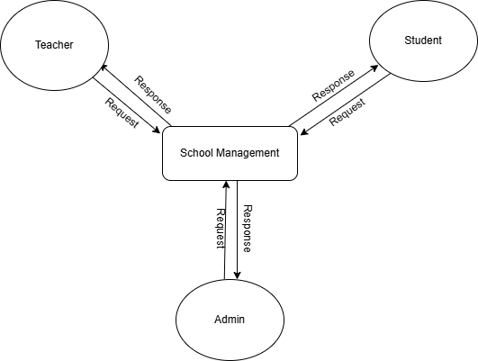

**Data Flow Diagram Level-0**

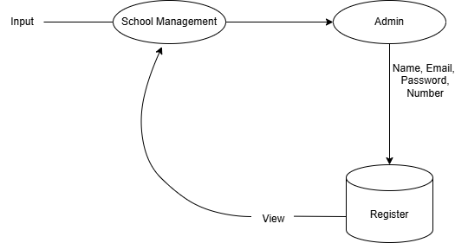

**Data Flow Diagram Level-2 (Register Admin)**

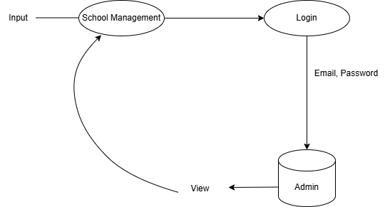

**Data Flow Diagram Level-2**

**(Login Admin)**

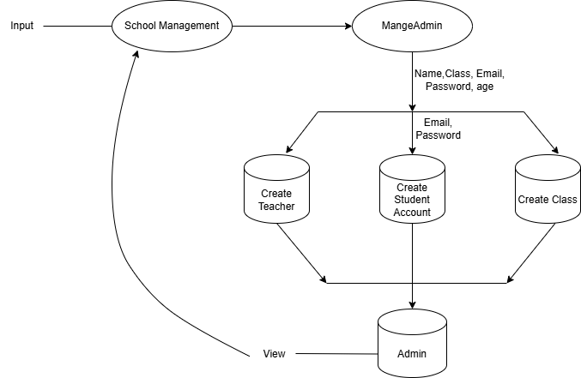

**Data Flow Diagram Level-2**

**(Manage Admin)**

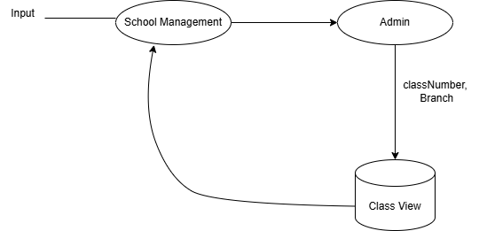

**Data Flow Diagram Level-2**

**(Create Class)**

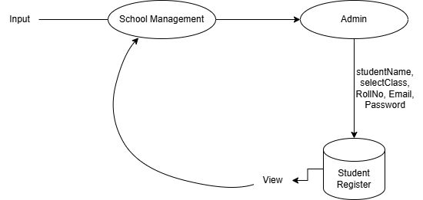

**Data Flow Diagram Level-2**

**(Create Student Account)**

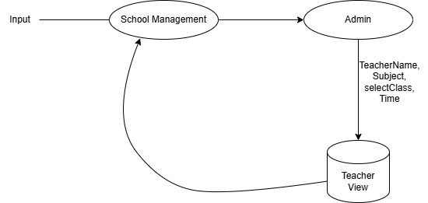

**Data Flow Diagram Level-2**

**(Create Teacher)**

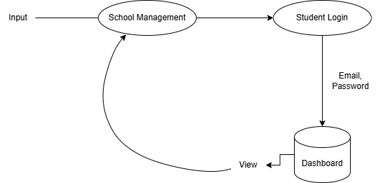

**Data Flow Diagram Level-2**

**(Student Login)**

* 1. **Entity Relationship Diagram:**

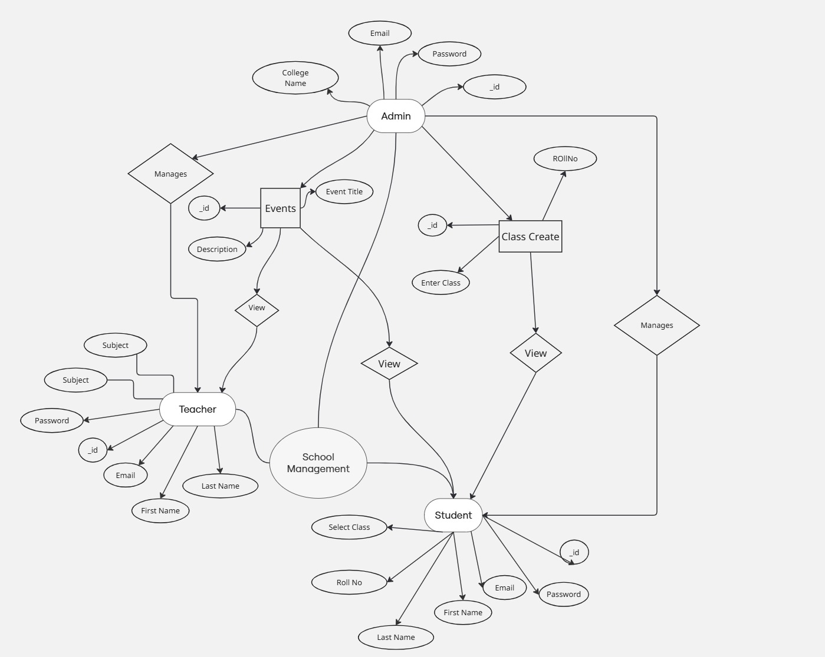

**Database Design**

Student Schema:  
{  
 name: String,  
 rollNum: Number,  
 password: String,  
 sclassName: { type: ObjectId, ref: 'sclass' },  
 school: { type: ObjectId, ref: 'admin' },  
 role: { type: String, default: "Student" },  
 examResult: [  
 {  
 subName: { type: ObjectId, ref: 'subject' },  
 marksObtained: Number  
 }  
 ],  
 attendance: [  
 {  
 date: Date,  
 status: { type: String, enum: ['Present', 'Absent'] },  
 subName: { type: ObjectId, ref: 'subject' }  
 }  
 ]  
}

Teacher Schema:  
  
{  
 name: String,  
 email: { type: String, unique: true },  
 password: String,  
 role: { type: String, default: "Teacher" },  
 school: { type: ObjectId, ref: 'admin' },  
 teachSubject: { type: ObjectId, ref: 'subject' },  
 teachSclass: { type: ObjectId, ref: 'sclass' },  
 attendance: [  
 {  
 date: Date,  
 presentCount: String,  
 absentCount: String  
 }  
 ]  
}

**3.6. User Interface Design:**

**Landing Page:-**

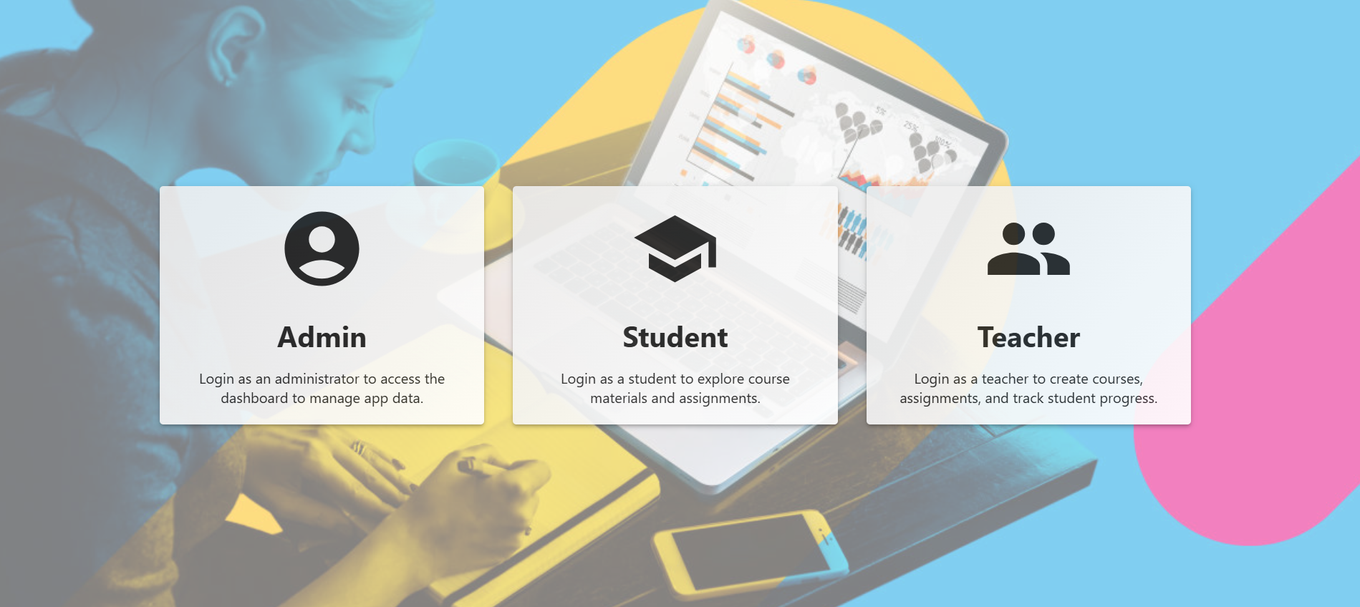

**Admin Register**

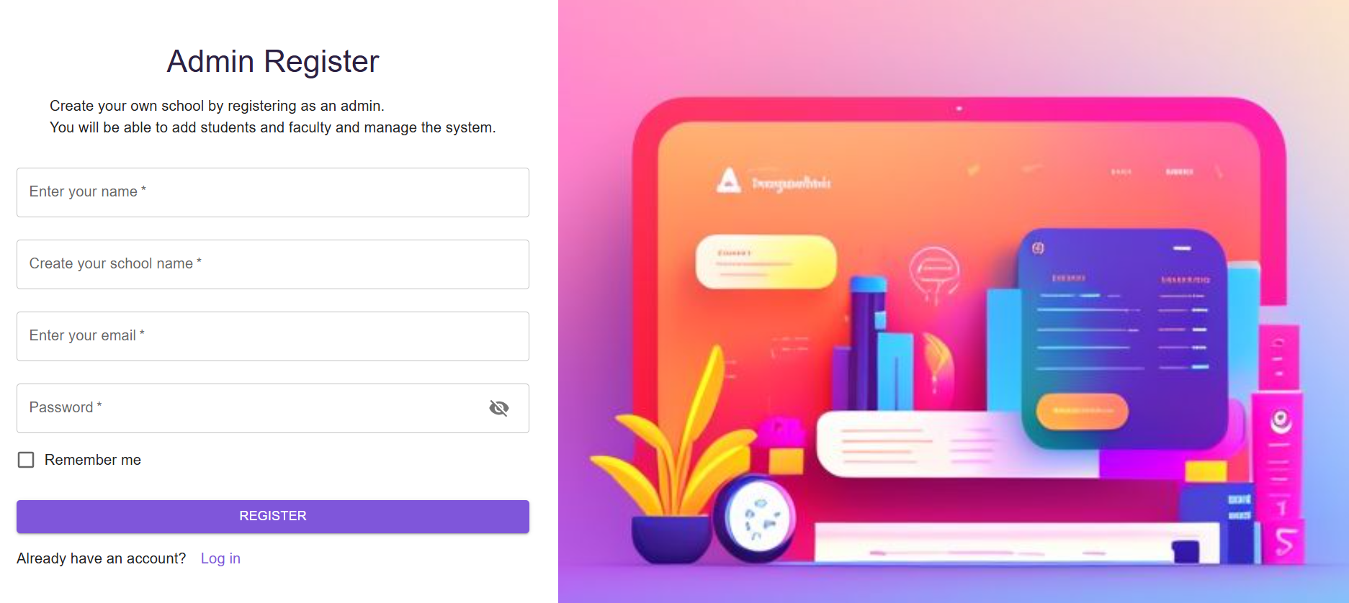

**Admin Login**

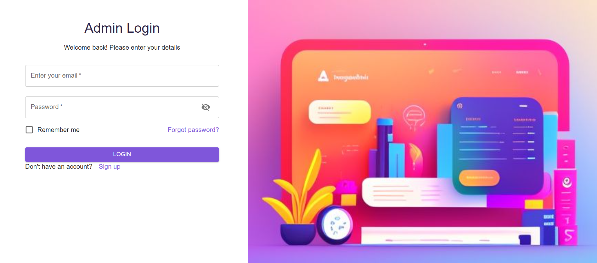

**Admin Dashboard**

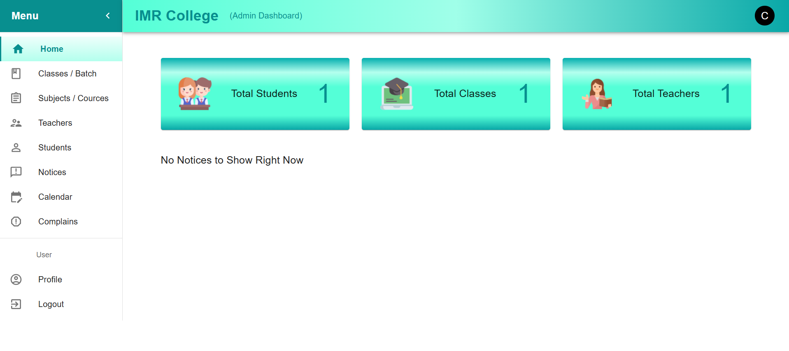

**Student Dashboard**

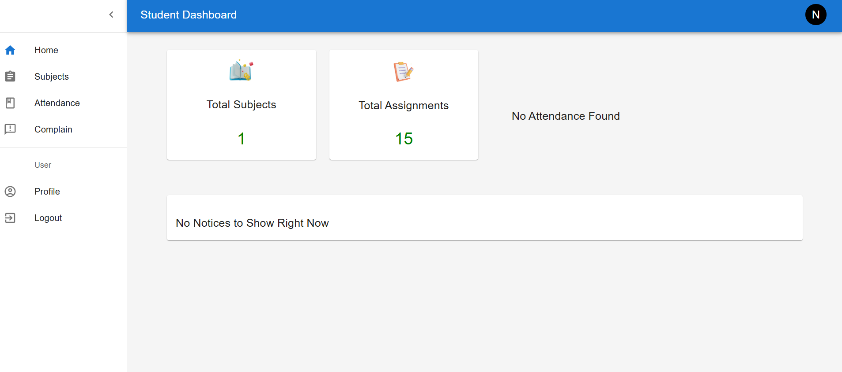

**Teacher Dashboard**

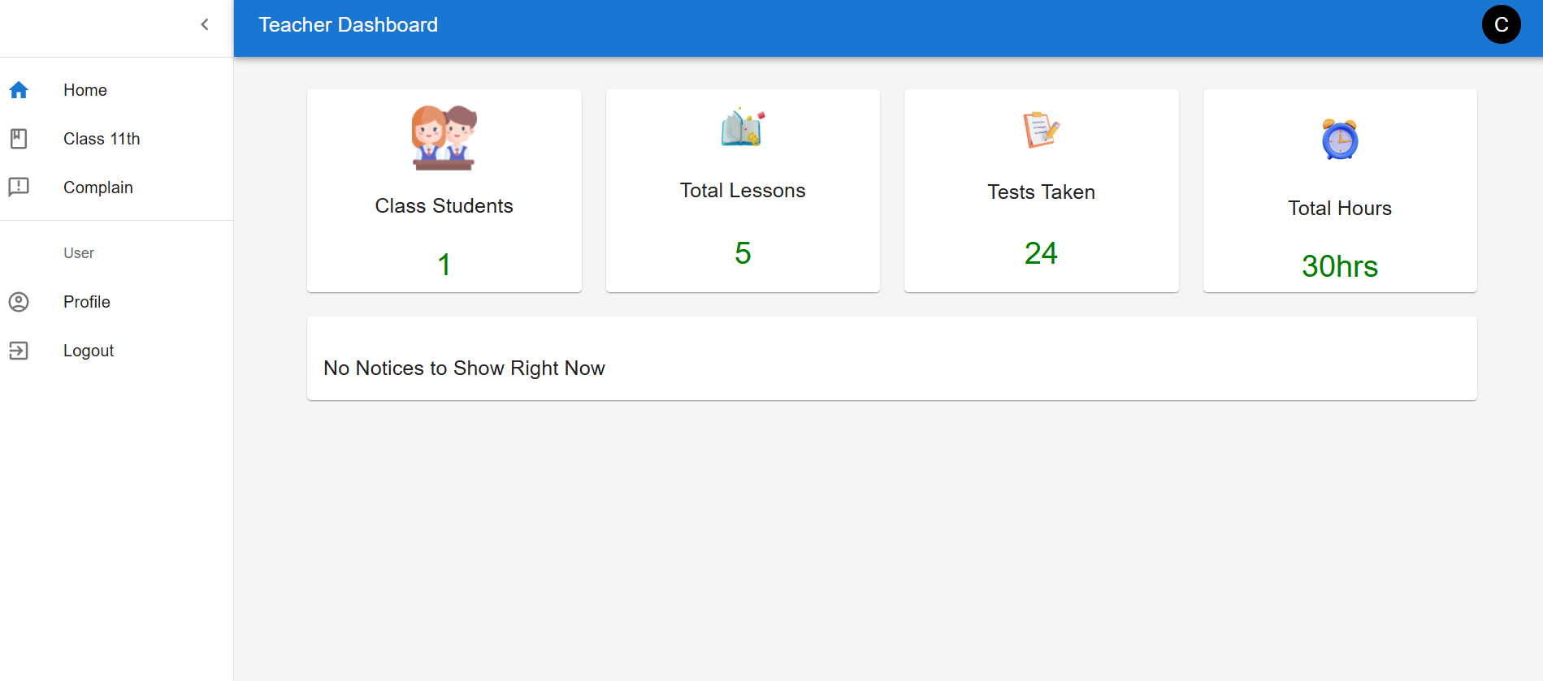

**CHAPTER 4**

**CODING**

* 1. **Algorithms:**

1. **User Registration and Authentication:**
   1. **User Registration:**
      1. Start
      2. Display the registration form to the user.
      3. User enters required details: name, email/phone number, password, etc.
      4. Validate the input fields.
      5. If any field is invalid, show an error message and ask for re-entry.
      6. Check if the email/phone number is already registered.
      7. If already registered, show an error message and ask for a different email/phone number.
      8. Save the user details to the database.
      9. Send a confirmation email/SMS to the user.
      10. End
   2. **User Login:**
      1. Start
      2. Display the login form to the user.
      3. User enters email/phone number and password.
      4. Validate the input fields.
      5. If any field is invalid, show an error message and ask for re-entry.
      6. Check if the email/phone number and password match a record in the database.
      7. If not, show an error message and ask for re-entry.
      8. Generate a session token for the user.
      9. Log the user into the system and redirect to the dashboard.
      10. End

**2. Student Account Creation**

1. **Start**
2. Admin selects **"Add New Student"** option from the dashboard.
3. Display the **Student Registration Form**.
4. Admin enters required student details: name, email, phone, gender, date of birth, class, roll number, etc.
5. Validate all input fields.
6. If any field is invalid, display an error message and prompt for correction.
7. Check if the student email/phone/roll number already exists.
8. If already registered, display an error message.
9. Save student details to the database.
10. Optionally, send login credentials to the student's email/SMS.
11. **End**

**3. Teacher Account Creation**

1. **Start**
2. Admin selects **"Add New Teacher"** option from the dashboard.
3. Display the **Teacher Registration Form**.
4. Admin enters required teacher details: name, email, phone, subject expertise, qualifications, etc.
5. Validate all input fields.
6. If any field is invalid, show an error message and prompt for correction.
7. Check if the email/phone is already registered.
8. If already registered, show an error message.
9. Save teacher details to the database.
10. Optionally, send login credentials to the teacher’s email/SMS.
11. **End**

**4. Admin Account Creation**

1. **Start**
2. Super Admin selects **"Create Admin"** option.
3. Display the **Admin Account Form**.
4. Super Admin enters admin details: name, email, password, phone, role permissions.
5. Validate all input fields.
6. If validation fails, show error message and prompt re-entry.
7. Check if the email/phone number already exists.
8. If already in use, show an error message.
9. Save admin credentials and permissions in the database.
10. Send confirmation email/SMS to the admin.
11. **End**

**5. Class Creation**

1. **Start**
2. Admin selects **"Create Class"** option from the dashboard.
3. Display the **Class Creation Form**.
4. Admin enters class details: class name/grade, section, academic year, assigned teacher (optional).
5. Validate the input fields.
6. If any field is invalid, show an error message.
7. Check if class with same name and section already exists for the academic year.
8. If exists, show an error message.
9. Save class details in the database.
10. Optionally assign students and a class teacher.
11. **End**
    1. **Code Snippet:-**

**Register Login Code(admin, Student, Teacher)**

1. import React, { useEffect, useState } from "react";
2. import { useNavigate } from "react-router-dom";
3. import {
4. Grid,
5. Paper,
6. Container,
7. CircularProgress,
8. Backdrop,
9. } from "@mui/material";
10. import {
11. AccountCircle,
12. School,
13. Group,
14. EscalatorWarning,
15. } from "@mui/icons-material";
16. import styled from "styled-components";
17. import { useDispatch, useSelector } from "react-redux";
18. import { loginUser } from "../redux/userRelated/userHandle";
19. import Popup from "../components/Popup";
20. import bgImage from "../assets/bg4.jpg";
21. const ChooseUser = ({ visitor }) => {
22. const dispatch = useDispatch();
23. const navigate = useNavigate();
24. const { status, currentUser, currentRole } = useSelector(
25. (state) => state.user
26. );
27. const [loader, setLoader] = useState(false);
28. const [showPopup, setShowPopup] = useState(false);
29. const [message, setMessage] = useState("");
30. const navigateHandler = (user) => {
31. const password = "zxc";
32. if (user === "Admin") {
33. if (visitor === "guest") {
34. const email = "admin@123.com";
35. const fields = { email, password };
36. setLoader(true);
37. dispatch(loginUser(fields, user));
38. } else {
39. navigate("/Adminlogin");
40. }
41. } else if (user === "Student") {
42. if (visitor === "guest") {
43. const rollNum = "1";
44. const studentName = "Sanki Singh";
45. const fields = { rollNum, studentName, password };
46. setLoader(true);
47. dispatch(loginUser(fields, user));
48. } else {
49. navigate("/Studentlogin");
50. }
51. } else if (user === "Teacher") {
52. if (visitor === "guest") {
53. const email = "tony@12";
54. const fields = { email, password };
55. setLoader(true);
56. dispatch(loginUser(fields, user));
57. } else {
58. navigate("/Teacherlogin");
59. }
60. }
61. };
62. useEffect(() => {
63. if (status === "success" || currentUser !== null) {
64. if (currentRole === "Admin") {
65. navigate("/Admin/dashboard");
66. } else if (currentRole === "Student") {
67. navigate("/Student/dashboard");
68. } else if (currentRole === "Teacher") {
69. navigate("/Teacher/dashboard");
70. }
71. } else if (status === "error") {
72. setLoader(false);
73. setMessage("Network Error");
74. setShowPopup(true);
75. }
76. }, [status, currentRole, navigate, currentUser]);
77. return (
78. <StyledContainer>
79. <Container sx={{ padding: "3rem" }}>
80. <Grid container spacing={4} justifyContent="center">
81. <Grid item xs={12} sm={6} md={4}>
82. <div onClick={() => navigateHandler("Admin")}>
83. <StyledPaper elevation={3}>
84. <AccountCircle style={{ fontSize: 100 }} />
85. <StyledTypography>Admin</StyledTypography>
86. Login as an administrator to access the dashboard to manage app
87. data.
88. </StyledPaper>
89. </div>
90. </Grid>
91. <Grid item xs={12} sm={6} md={4}>
92. <StyledPaper elevation={3}>
93. <div onClick={() => navigateHandler("Student")}>
94. <School style={{ fontSize: 100 }} />
95. <StyledTypography>Student</StyledTypography>
96. Login as a student to explore course materials and assignments.
97. </div>
98. </StyledPaper>
99. </Grid>
100. <Grid item xs={12} sm={6} md={4}>
101. <StyledPaper elevation={3}>
102. <div onClick={() => navigateHandler("Teacher")}>
103. <Group style={{ fontSize: 100 }} />
104. <StyledTypography>Teacher</StyledTypography>
105. Login as a teacher to create courses, assignments, and track
106. student progress.
107. </div>
108. </StyledPaper>
109. </Grid>
110. {/* <Grid item xs={12} sm={6} md={4}>
111. <StyledPaper elevation={3}>
112. <div onClick={() => navigateHandler("Parent")}>
113. <EscalatorWarning style={{ fontSize: 75 }} />
114. <StyledTypography>
115. Parent
116. </StyledTypography>
117. Login as a parent and track student progress.
118. </div>
119. </StyledPaper>
120. </Grid> */}
121. </Grid>
122. </Container>
123. <Backdrop
124. sx={{ color: "#fff", zIndex: (theme) => theme.zIndex.drawer + 1 }}
125. open={loader}
126. >
127. <CircularProgress color="inherit" />
128. Please Wait
129. </Backdrop>
130. <Popup
131. message={message}
132. setShowPopup={setShowPopup}
133. showPopup={showPopup}
134. />
135. </StyledContainer>
136. );
137. };
138. export default ChooseUser;
139. const StyledContainer = styled.div`
140. // background: linear-gradient(to bottom, #411d70, #7FFFD4);
141. // background: url(${bgImage});
142. background: linear-gradient(rgb(255, 255, 255, 0.5), rgb(255, 255, 255, 0.5)),
143. url(${bgImage});
144. background-size: cover;
145. background-repeat: no-repeat;
146. background-position: center center;
147. min-height: 100vh;
148. display: flex;
149. justify-content: center;
150. align-items: center;
151. // padding: 1rem;
152. // padding-top: 10vh;
153. @media (max-width: 768px) {
154. min-height: 190vh;
155. // padding-top: 5vh;
156. }
157. `;
158. const StyledPaper = styled(Paper)`
159. padding: 20px;
160. text-align: center;
161. cursor: pointer;
162. opacity: 0.9;
163. background: linear-gradient(135deg, #ededed, #ffffff);
164. &:hover {
165. background: linear-gradient(135deg, #088f8f, #1f1f38);
166. color: white;
167. transition: background-color 0.3s ease, color 0.8s ease;
168. }
169. `;
170. const StyledTypography = styled.h1`
171. margin-bottom: 15px;
172. `;

**CHAPTER 5**

**CONCLUSION**

The **School Management System** offers a transformative solution for digitalizing traditional school operations and enhancing educational administration. With its intuitive interface, role-based dashboards for Admins, Teachers, and Students, and comprehensive modules—such as student and teacher management, class creation, blogs, events, and subscriptions—it streamlines daily school tasks and fosters a more organized academic environment.

However, for long-term success and adoption, the system must address critical areas such as **robust security, data privacy**, and **scalability**. Implementing secure login systems, encrypted data storage, and regular backups can enhance trust and reliability. Additionally, adopting a **cloud-based infrastructure** will ensure the platform can scale efficiently with growing student populations and expanding institutional needs.

To improve engagement, the system could benefit from **mobile application support**, **notification alerts**, and **gamified learning dashboards** for students. Features such as **performance tracking**, **parent-teacher communication tools**, and **digital attendance reports** can further enrich user experience and academic accountability.

Building a strong sense of **transparency and communication** within the platform is also vital. Integrating features like student progress reports, teacher feedback systems, and a structured complaint management process will promote clarity and trust among users. Ensuring that parents, teachers, and students are all part of a cohesive digital ecosystem fosters collaboration and academic growth.

Finally, continuous improvement through **user feedback**, **training resources**, and **integration with third-party educational tools** (like online classrooms and exam portals) will keep the system relevant and user-centric. By evolving with educational trends and user expectations, the School Management System can become a vital tool for modern schooling and set a benchmark in academic digital transformation

**CHAPTER 6**

**BIBLIOGRAPHY**

**School Management & Education Platforms in India**

These platforms offer insights into existing solutions and can inspire features for your system:

* **Fedena** – <https://fedena.com/>
* **MyClassCampus** – <https://myclasscampus.com/>
* **Entab (CampusCare)** – <https://www.entab.in/>
* **Eduflex** – <https://www.eduflex.co.in/>
* **School ERP India** – <https://www.schoolerpindia.com/>

**General Education & Administration Resources**

These resources provide information about educational standards, academic management, and administration best practices:

* NCERT (National Council of Educational Research and Training**)** – https://ncert.nic.in/
* CBSE (Central Board of Secondary Education) – <https://www.cbse.gov.in/>
* UNESCO Education Resources – <https://www.unesco.org/en/education>
* MHRD (Ministry of Education, Government of India) – <https://www.education.gov.in/>

**Technology Resources (for Development)**

MERN Stack Development:

* Chai aur React (Frontend) – [YouTube Playlist](https://youtube.com/playlist?list=PLu71SKxNbfoDqgPchmvIsL4hTnJIrtige&si=xZrRw00KHTyAR7o_)
* Chai aur Backend (Node + Express + MongoDB) – [YouTube Playlist](https://youtube.com/playlist?list=PLu71SKxNbfoBGh_8p_NS-ZAh6v7HhYqHW&si=FeAc1a1nv9m8DZU4)

Cloud Integration:

* Cloudinary(for managing media) – <https://cloudinary.com/documentation>

Authentication:

* JWT (JSON Web Token**)** – <https://jwt.io/>